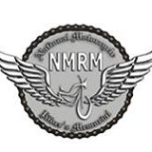
Is proud to announce the 2nd. Annual benefit auction to be held in Spokane

A Fundraising Event in the Spokane Valley

Saturday, September 20, 2014, Preview 2:00; Auction 3:00; at Daley’s Cheap Shots
6412 E. Trent Ave. Spokane Valley, WA. 99212

Join us for
A Live Auction
With LOADS of exciting items from tools & tattoos to biker apparel & accessories
A Silent Auction
Bids may be placed at any time until 6:30pm. Winners will be announced after dinner
A Benefit Dinner
Prepared especially for this event by the Daley’s Cheap Shot’s staff
Served from 5:00-7:00pm

For more information call:
Daley’s Cheap Shots at (509) 535-9309
David Castner at (509) 230-6796
Row Ennis at (503) 851-5792

